|  |
| --- |
|  |
| Coldplay Fan Page  Web Authoring - 5N1910 |
| |  |  |  | | --- | --- | --- | | Carl Ferdinand, Peralta 17-1819 | 3/14/18 | CSC-B | |

Contents

Introduction 2

Target Market 2

What the website offers? 2

Information Architecture (IA) 3

Wireframe 3

Home – Desktop 4

4

Home – Mobile 5

Contact Us – Desktop 7

Contact Us – Mobile 8

Presentation 9

Contrast 9

Repetition 9

Alignment 9

Proximity 9

Web Development Tools 10

Text editor 10

# Introduction

The theme that I have chosen for my website is Coldplay. I have chosen Coldplay as my focus because my huge interest with the band and their songs. Coldplay’s recent album is associated with multiple colours, also showing a geometric pattern that represent the Flower of Life. I have done my research on the local domain on Coldplay, and “Coldplay.com”, “Coldplay.co.uk”, and “Coldplay.eu” were either taken or unavailable. Fortunately, I was able to find the availability of “Coldplay.ie”

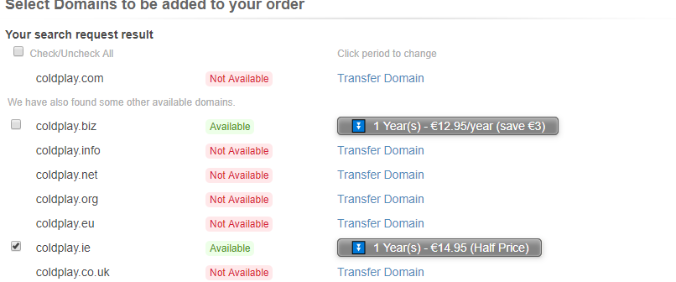

# Target Market

The target audience/market for this website is very broad. Coldplay has been active in the music industry for several years since 1996. The fan base is in ranges of young to old. But mainly this website is aimed towards younger and new fans of Coldplay who wishes to seek more information about the band.

# What the website offers?

What this website provides 4 pages; Home, About, Albums, and Contact Us. It offers the history of the band, a short biography of each of the band members, (Martin, Bukland, Champion, Berryman) and also the songs of each of their 7 album released albums throughout the years. There is also a “Contact Us” page where all visitor who sign up to the Newsletter will receive a free monthly subscription about Coldplay and Rock genre.

# Information Architecture (IA)

The sitemap for my website is very straight forward, with 1 level in my website. It has four level 1, Home, About, Albums, and Contact Us.

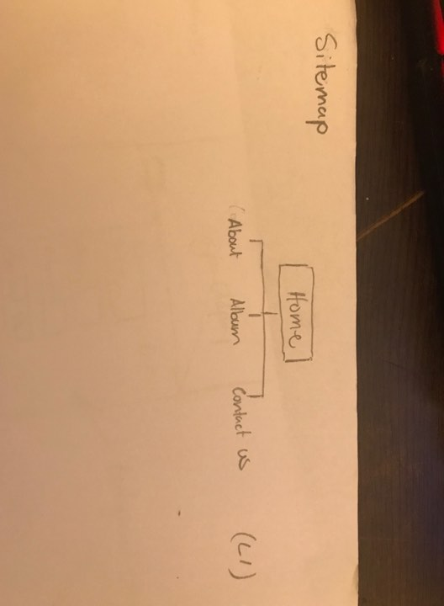

The navigation is a very important interface that the users will use to get to the pages defined by the sitemap. These diagrams are very important to plan the website.

# Wireframe

I have sketched 2 pages from my website, the Home and Contact Us pages. I have sketched a desktop and mobile version on both pages to understand the variations of both versions.

## Home – Desktop

## 

## Home – Mobile

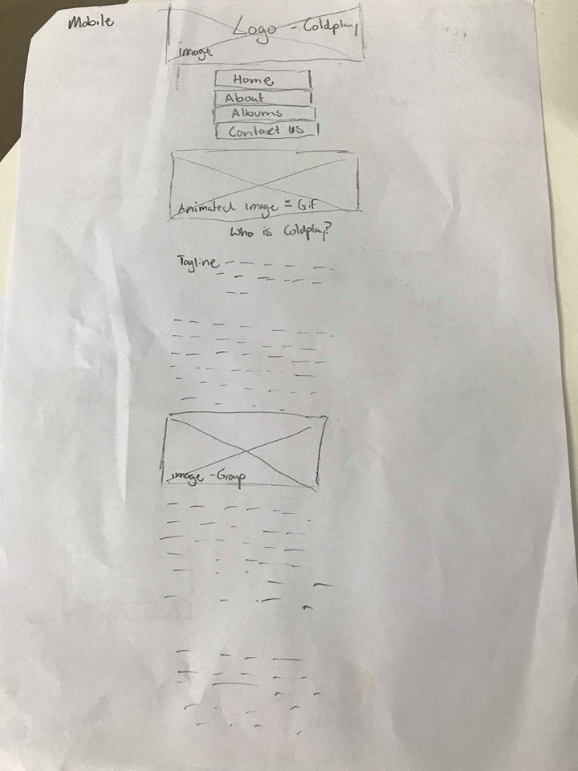

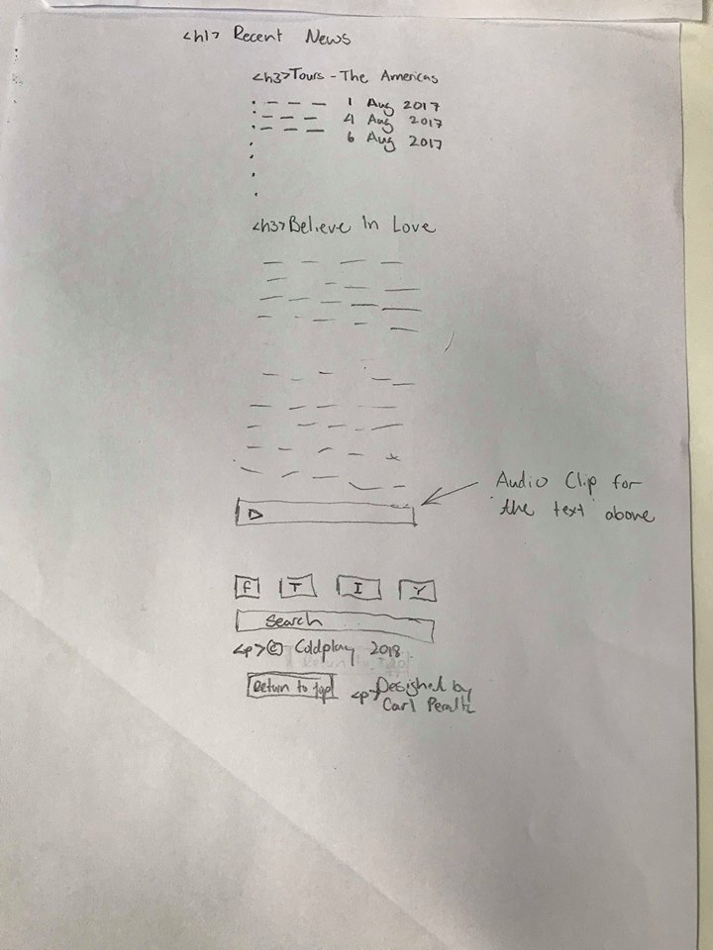

## Contact Us – Desktop

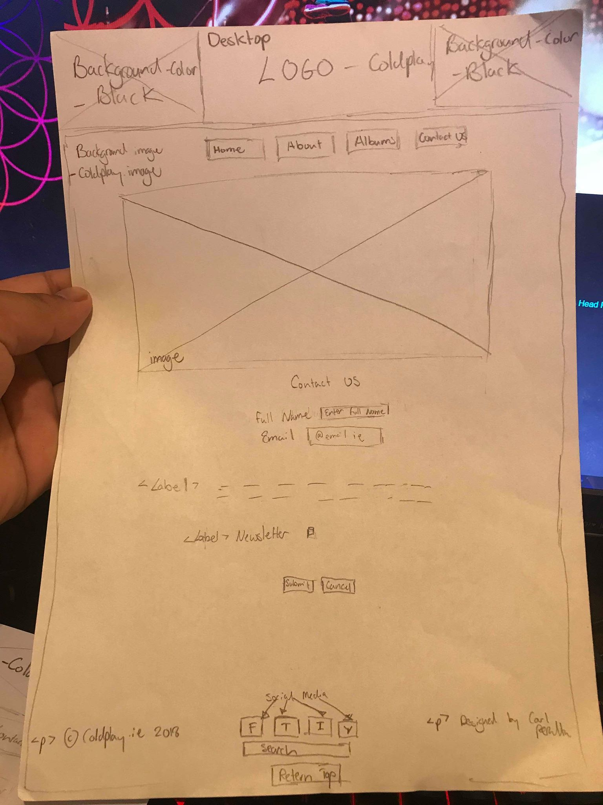

## Contact Us – Mobile

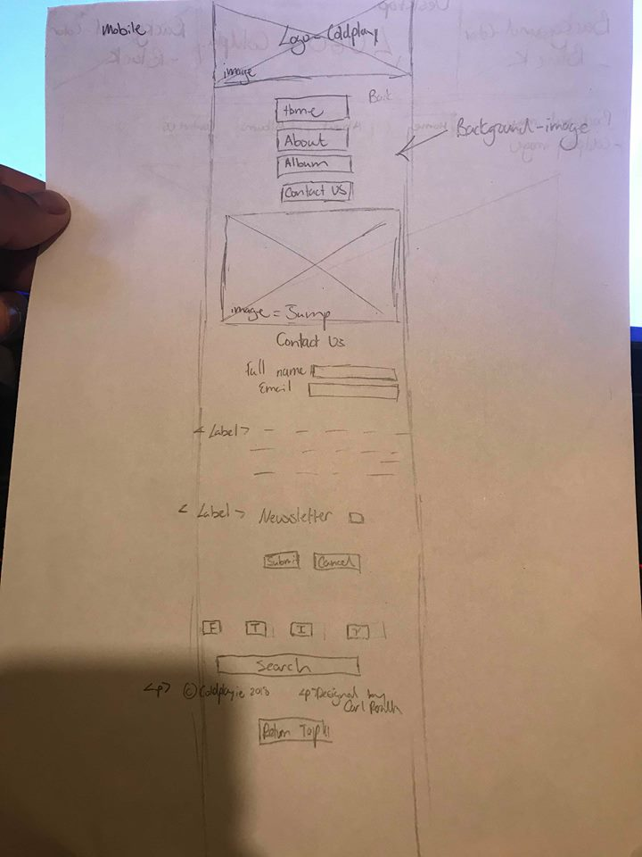

# Presentation

## Contrast

Contrast is one of the main principles of design. Contrast happens when 2 or more elements are diverse. The greater the difference the grater the contrast could be. The secret to working with contrast is making sure that differences are obvious to a naked eye. How I implemented contrast on my website is the background-image to be dark and the text colour was made white/light colours to properly read the paragraphs.

## Repetition

Repetition usually shows up on websites as the repeated visual element which appears in all pages of the websites. For example, <footer> and <header>. Element that can be repeated with effectiveness are colours, textures, font, shapes, images, videos, etc. These elements are repeated several times throughout the website to keep the consistency of the theme alive. How I used repetition is the constant use of images that would be used in mostly throughout the pages, just to keep in mind the theme of Coldplay.

## Alignment

Alignment is the integral part of most website design that no one realizes it’s there, it is well hidden as an initial design element that is allocated in the background. It is the backbone of all websites. An alignment could be seen in the <article> section. Below the heading “Who is Coldplay?” there is a quote that has colour yellow as a text, that is centre which is aligned in the <article>.

## Proximity

Proximity in design simply means that objects near each other are seen as a unit. It really is that simple and it’s something you see every day. On the website, I have added images with text to help understand and have an idea on what its been said on each paragraph.

# Web Development Tools

## Text editor

Text editor is a system or program that used to allow users to edit text of a language. This could be run by a computer. Some types of text editors could be: Notepad, Notepad++, Eclipse, Brackets, and Dreamweaver etc. These example all have different functions when it comes to different languages

## WYSIWYG editor

WYSIWYG editor is a program/system where content (text and graphics) could be changed and edited in a program. It appears when its printed or displayed as a finished product, such as a printed document, web page, or slide presentation.

## Webpage builder

Website builder are the tools that occasionally allows the construction of the websites without editing a manual code. They fall to 2 types of builders. There would an online propriety tools that were offered by web hosting companies. There is also an offline software which could on a private PC, creating pages that could be publish on any host.

## Content Management System

Content Management Systems (CMS) is a computer application or set of programs that are used to create and manage digital content for clients. CMS are typically used for web content management and enterprise content management

## Web Development Tools

Licensing fees are paid as part of an agreement that defines the terms under which a tangible property is licensed for use by one party to another. Building a website, you need a reasonable team that will have a specific job. i.e. A programmer will deal with the raw code back-end of the website and a graphic designer deals with the design front-end of the website.

A typical website will take 14 weeks at a minimum from start to launch. This includes 2 weeks discovery, 3 weeks design, 3 weeks design revisions, 3 weeks initial development, and 3 weeks of modifications

The tools that I used for editing my website is photoshop. what I did in photoshoot was, scaling down the images to fit the website, i.e. scales down the social media photos to match with the footer.

The link I used to upload the site to a server was FTP (File Transfer Protocol)

## 

# Report on Future Planning

## Updating Content on a Webpage

The procedure I would use to update content on the site is outlined below. For example, to update the Recent News section, the procedure would be:

* Add the new content and code it with the correct semantic HTML tags.
* Style as appropriate in the CSS
* Constantly updating the Recent News (aside).
* I tested all possible outcomes of the layout of the newly updates
* Checking all the different screen sizes for desktop, tablet and smartphone
* Before uploading this update, I wanted to make sure that both HTML and CSS had no syntax errors.
* Validated the files using the online W3C and CSS validation services.
* Once all tested I would upload it to the servers.

## Creating a new page

The procedure I would use to creating a new page on the site is outlined below. For example, to create a new page for the store. The procedure would be:

* Start with a sitemap and wireframe for the new page,
* Update all the navigation to all the current pages in the websites.
* The new page will have the same layout as the rest, it’ll have a generic online store selection
* The type of item that would be sold are: T-Shirts, Hoodie’s, Banner, Albums, Phone Cases, and Mug etc. The new page should be link with the other pages. Once all the design phase is ready to go.
* Start typing up the HTML and CCS. After all the code is typed up, making sure no error occurring,
* Use W3C and CSS validation service to check. To test the successful rate, the new page is shown to user to receive feedback.

## Evaluating the Project

I have enjoyed using HTML and CSS for this project, I’m hoping to continue Web Authoring in 3rd level. I have missed out some part that I could’ve added throughout my project. For example, adding a YouTube file to one of the pages or expanding the footer. I have not been able to get my burger menu functional, though I have added the necessary code needed but failed to make it functional.

I also had a go with an album slideshow, but it took the most time consuming to produce. Studying and applying JavaScript for the slideshow just too complicated to execute. I plan on studying JavaScript during summer to understand the basic concept of JavaScript.